**Candidate Project Requirement**

The following are the changes that I have implemented to make sure the requirements were met in accordance with the provided guidelines.

Last remaining development item for the iteration:

1. Implement the RemoveEquipmentOnCarton action on the CartonController, right now it is just throwing a BadRequest.

For the above requirement, I had made sure to avoid the Bad request on the first stage, and then I started implementing the code part. Initially I had faced errors regarding the Action Result sometimes ‘not return any values’, but I had tried to avoid the count of loops in the method so that I can get the expected output.

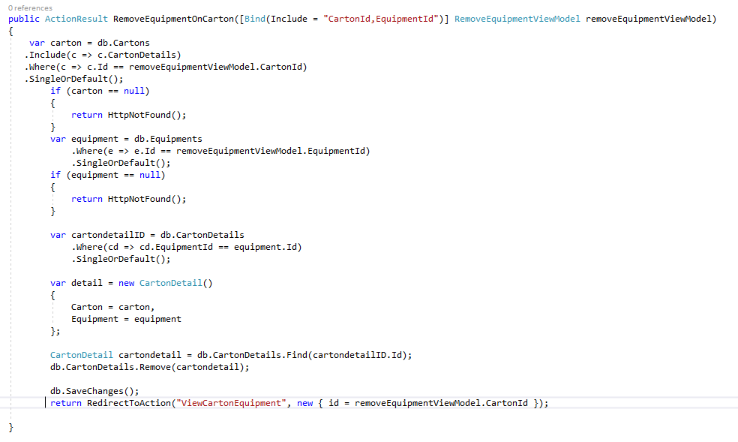

Our customers has reported the following bugs:

1. We can delete empty cartons from the system, but cannot delete cartons that have items. We should be able to delete a carton at any time.

Yes this is an issue and to avoid this, I had made sure to get the count of equipment Id’s under a particular Carton, and then check if the count is 0. If it is 0 then we can go ahead and delete the carton, else it will remain as is.

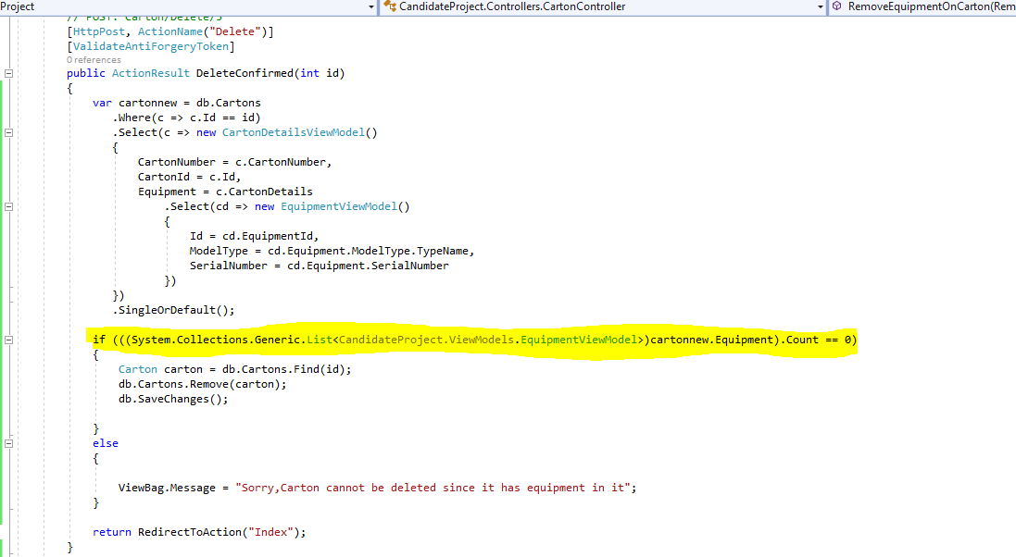

2. We can add the same piece of equipment to 2 different cartons, this doesn’t make sense. We should only be able to add a piece of equipment to 1 carton, once a piece of equipment is on a carton it should be unavailable to place on another carton.

This is a bit tough to figure out but after a long thought process, I came to realized it is not necessary to have the count of Carton ids in the Add Equipment Action. I just removed it and it satisfies the requirement.

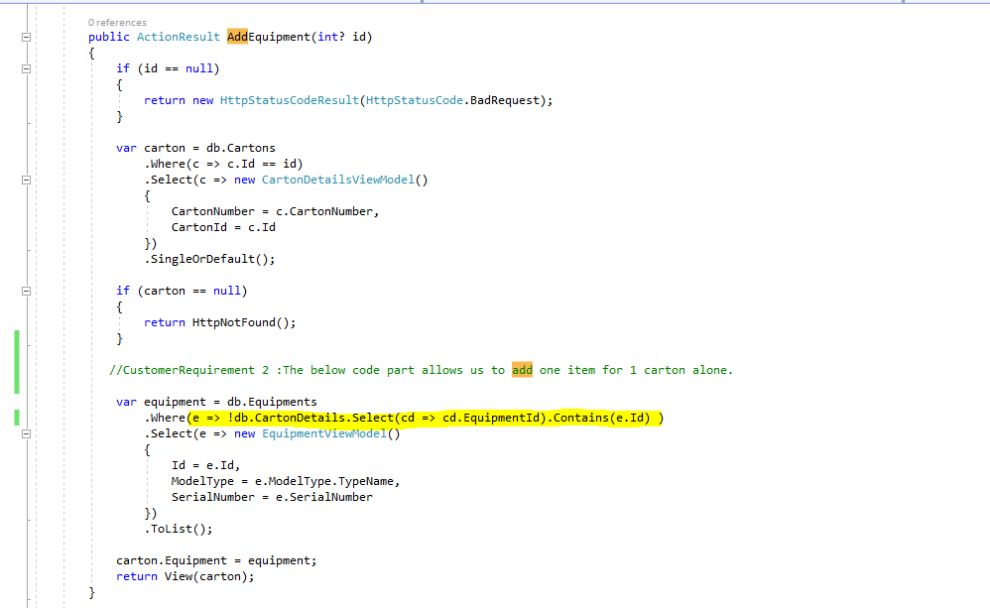

3. Our cartons can physically hold up to 10 pieces of equipment, but the application allows us to put an unlimited number of equipment on the carton, please only allow up to 10 pieces of equipment on the carton.

I had introduced a condition similar to the count process I had used for Deletion and it works as expected.

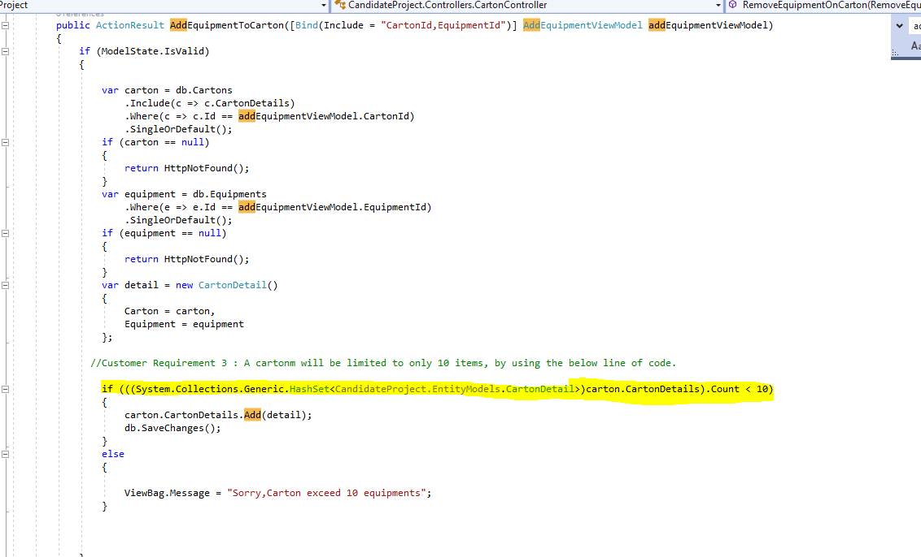

Our customers have asked for the following enhancements:

1. The carton index screen should show the # of pieces of equipment on the carton

I had added a new field named Equipment Count on the Index screen to show the users, the count of items in the carton. And to add this I have to follow certain strategy by adding the new column value to CartonViewModel as well as in the Index.html page.

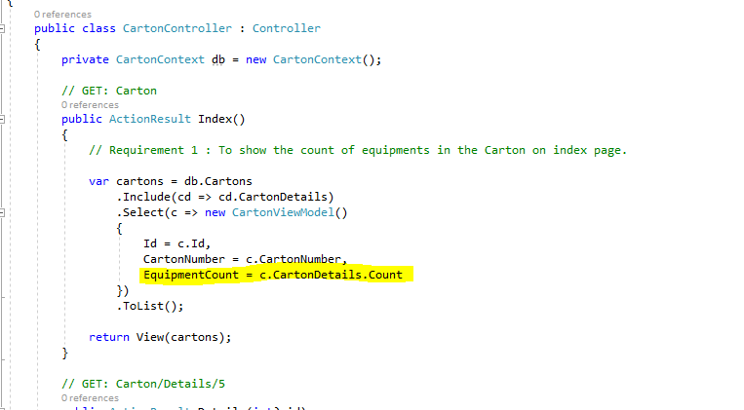

2. We need a quick way to remove all the items from the carton with 1 click.

This requirements needs an additional field to be added to the index page. And the following is the implementation I followed.

